Strayer University

**Mobile Devices and Self-Service E-Commerce.**

Week 10

**Assignment**

for the

Course of

**human-computer interaction**

.09/11/17

By

Kennedy Kabaso.

Professor: Edeki Charles.

**Mobile Devices and Self-Service E-Commerce**

This paper is about the **Mobile Devices and Self-Service E-Commerce.** The new startup e-Commerce company [Sports R US](http://www.sportsrusil.com/) has hired me to provide a convenient self-service solution for customers accessing sports products. As the project manager for this task, I will put a team together which will build the Web application which would be available on mobile devices like smartphones, tablets, laptops and notebooks. In addition, we would make the application work on multiple Web browsers such as Chrome, Internet Explorer, Firefox, Safari and others to support self-service tasks. Moreover, we will provide a Human-Computer Interaction (HCI) guidance for the design and implementation of this service. Therefore, I will start by describe some terms to simplified the whole task, design Sports R US home page for the mobile device and the self-service Web page which would make it easy to review products, checkout using mobile devices and it is going to be achieve using Microsoft Visio. Then I will suggest a prototype which is necessary for the task, talk about the type of evaluation method to use on the Web design for the best user experience and finally, discuss some key details of how the mobile self-service will be implemented on various mobile devices.

**Description of some terms.**

Before I go any further, I would like to talk about Purpose and goals of a mobile self-service. Web self-service is a type of electronic support that allows customers to access information and perform routine tasks over the Internet, without requiring any interaction with a representative of a company. Web self-service is widely used in customer relationship management and employee relationship management. The purpose is to enables marketing communication between customers and the company using an app through chat, voice and video. The Target segmentation is a process of dividing people into homogeneous subgroups based on defined criterion such as product usage, communication behaviors and media use. Audience needs may be some wants, necessities or audiences already have and those they want in their lives. The Resources necessary to achieve the desired outcome are the economic or productivity factor required to accomplish an activity. In this case are the mobile devise which is a latest on called the e-readers. The design of the Website for mobile devices is a responsive website automatically changes to fit the device you're reading it on. And finally, a mobile user interface (mobile UI) is the graphical and usually touch-sensitive display on a mobile device, such as a smartphone or tablet, that allows the user to interact with the device's apps, features, content and functions.

**Design each of the following using Microsoft Visio**

I have designed the responsive website which can be viewed on different mobile devices below. It is will look different depending on the device you are using. Customer for the Sports R Us Inc would be able to buy different sports equipment using the self-service which is shown below and be able to continue shopping without any problem. This can be done by adding their order to the shopping cart and be able to checkout at the end of the order without any problem. The order would be done and the shipment without any problem and the transaction will be secured because the site is protected.

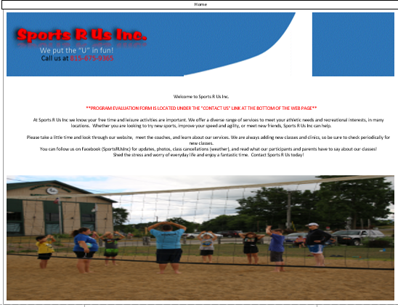

A responsive website viewed on a mobile phone figure.

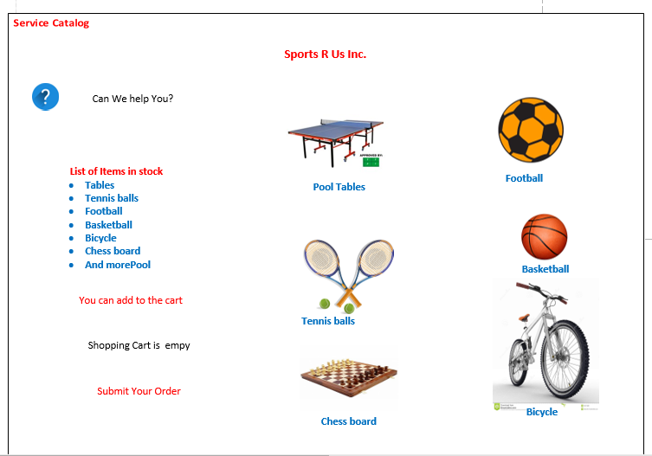

A Self-Service Website with all the Goods for Sports R Us Inc.

**Recommend one (1) prototype that could be created.**

Before I can talk about the best recommended prototype, I would like to define what it is and its important. According to the book (Preece 386) “prototype is one manifestation of a design that allows stakeholders to interact with it and to explore its suitability; it is limited in that a prototype will usually emphasize one set of product characteristics and de-emphasize others” When designing any software application, it is important to prototyping because they

are useful when discussing or evaluating ideas with stakeholders. In addition, they are a communication device among team members, and an effective way for designers to explore design ideas. The activity of building prototypes encourages reflection in design. Moreover, they answer questions and support designers to come out with the best alternatives. Since they wanted the Web application that would be available on mobile devices and needs to work on multiple Web browsers, therefore I would recommend High-fidelity prototypes. It is the type that simulates the real site’s functionality and design details which is the best need for the above task.

**Determine the type of evaluation method to use in a Web design for the best user experience.**

To better understand how user are going to experience, an evaluation is going to be conducted. The primary objective of the evaluation process is to produce data upon which to determine usability solutions. To understand users’ usage behaviors of mobile apps, usability testing and evaluation methods are undertaken. Such usability evaluation methods seek to ensure that users can operate the web app mobile efficiently, effectively, and satisfactorily. Therefore, the method of evaluation I use is the Natural settings involving users. Its aim is to evaluate people in their natural settings. They are used mostly to help identify opportunities for new technology, establish the requirements for a new design and facilitate the introduction of technology. This type of evaluation will be suitable for the web for the best user ‘s experience.

**Provide key details of how the mobile self-service will be implemented on various mobile devices**.

The Mobile Self-Service applications enable smartphone, tablet, and other smart device interactions with the customers to drive down the costs while improving their experience. Nowadays, there has been a growing in the number of people using smartphone, and the device. This make them to be near their phone, as a result an easy to navigate web site which is going to work on different device is the best solution to meet their needs. Therefore, a responsive web design is needed for this task and the mobile self-service. The responsive design is the one in which the design and development of the website should respond to the user's behavior and environment based on screen size, platform and orientation. It consists of a mix of flexible grids and layouts, images and an intelligent use of CSS media queries. In addition, it is an approach to web design aimed at allowing desktop webpages to be viewed in response to the size of the screen or web browser one is viewing with and it works in almost all of them. Mobile self-service was becoming expensive to the both the customer and the company. Therefore, the has been an introduction of automated customer care platforms such as interactive voice response (IVR) systems and web-based portals, to enhance customer service and reduce the costs associated with agent-based support. Mobile self-service will be implemented on various mobile devices by promoting the channel IVS and SMS. The use of IVR or SMS to offer basic self-care services is good to continue promoting the channel for self-service. All kind of Smartphones, can provide mobile customers with a convenient way to access a variety of online applications (“mobile apps”) that can include customized business applications to support customer self-service needs as an alternative to always requiring real-time live assistance. It can be made possible by the method on which it is done. To make this simple whenever the customer runs into a problem, the live assistance can be easily accessible.

Mobile self-service applications on the other hand can come with some challenges such as a convenient platform for easily developing, maintaining, and running the apps of the mobile. In addition, it can be a problem of trying to reach the customer assistance by clicking on the apps.

**Conclusion**

Finally, after all the process is done about the Mobile self-service applications and the building of the responsive web design which can work on all the mobile devices, different test would be done to ensure the success of the task. Customer would be able to order the products on the company website without any problem with the apps. In addition, they will be a continuous maintenance of a site. Mobile self-service applications would be the nest booming industry and I hope some of the challenges would be worked upon in the future. And I hope Sports R Up would be selling the products on using the self-service application without any problem.

**Bibliography**

1. (Preece 386) Preece, Jenny, Helen Sharp, Yvonne Rogers. *Interaction Design: Beyond Human-Computer Interaction, 4th Edition*. John Wiley & Sons UK, 2015-05-18. VitalBook file.
2. <https://strayer.vitalsource.com/#/books/9781119088790/cfi/6/26!/4/2/16/16/6/12/4/10/2@0:17.0>
3. (Preece 459) Preece, Jenny, Helen Sharp, Yvonne Rogers. *Interaction Design: Beyond Human-Computer Interaction, 4th Edition*. John Wiley & Sons UK, 2015-05-18. VitalBook file.
4. <http://www.develop-online.net/tools-and-tech/designing-an-mmo-ui/0117165>